**Resume Matcher**

**Document Number: 0.1**

**Document Version: 0.2**

**Confidential**

*Proprietary & Confidential*

**Copyright 2017 - 2018 INCEDO INC**. All Rights Reserved. No part of this document may be reproduced, stored in a retrieval system, distributed or transmitted, in any form, or by any means, electronic or otherwise, including photocopying, reprinting, or recording, for any purpose, without the express prior written permission of Incedo Inc.

**REQUESTS** For information requests or for obtaining permission for the use of this work, please submit a written request to: Marketing and Communications, Incedo Inc, Plot No. 248 Udyog Vihar, Phase IV, Gurgaon - 122015. Email: communications@incedoinc.com

**Document Revision History**

|  |  |  |  |  |  |
| --- | --- | --- | --- | --- | --- |
| **S.No.** | **VERSION NO.** | **DATE** | **AUTHOR** | **APPROVAL BY** | **Remarks** |
| 1 | 0.1 | 31-01-2018 | Dibya  Gnana Prakash  Mahendra Selvi | Incedo Hackathon Evaluation Team / HR Team |  |
|  |  |  |  |  |  |
|  |  |  |  |  |  |
|  |  |  |  |  |  |
|  |  |  |  |  |  |

**Table of Contents**

1. Abstract 5

2. Solution Approach 5

3. Design Architecture 6

4. STATE CHART DIAGRAM 7

5. Business Impact: 7

6. Future Scope 8

# Abstract

As per normal process, Recruitment HR’s has to go through all the resumes one by one manually. This process is highly time consuming process and there is a chance for missing potential Profiles.

“Resume Matcher” is an intelligent tool for matching Resumes for the JD Description and will gives ranking for the Profiles. This application will Display all the relevant Profiles according to the key skills and experience.

There is a watcher service which will check for new file in the input location and index for searching. Lucene - full text search library will scan all the resumes from the location and then it will index all the key skills. Search has two principal stages: indexing and retrieval. When HR will hit the Search button by choosing some keywords, it will show the profile list with the matching key skills from the JD.

# Solution Approach

**Problem:** The problem is that the present are not much flexible and efficient and time saving. It requires HR, to search manually than also they might not get the genuine information of the candidate. Beside HR team saves more man power to scrutinize the resumes of the candidates.

**Need of Resume Matcher**: In the present system the HR has to search each and every information regarding there resume in a manual which takes large amount of time. And HR team requires more man power to scrutinize the resumes of the candidates. So that motivated to build a solution that is more flexible and automated.

**TF-IDF algorithm** used to rank the resumes based upon the input keyword given for the JD.

Lucene implements a variant of the TF-IDF scoring model.

1. Apache Lucene is used to search and index keywords from resumes based on JD skill sets.
2. As per the key skills from JD, we are giving the sorted Profiles.
3. HR will able to download resume from the web application where it’s sorted the top ranking resumes.
4. Ranking Score also one of the awesome feature to choose the best Profile among all.

The factors involved in Lucene's scoring algorithm are as follows:

1. tf = term frequency in document = measure of how often a term appears in the document
2. idf = inverse document frequency = measure of how often the term appears across the index
3. coord = number of terms in the query that were found in the document
4. lengthNorm = measure of the importance of a term according to the total number of terms in the field
5. queryNorm = normalization factor so that queries can be compared
6. boost (index) = boost of the field at index-time
7. boost (query) = boost of the field at query-time

# Design Architecture



# STATE CHART DIAGRAM

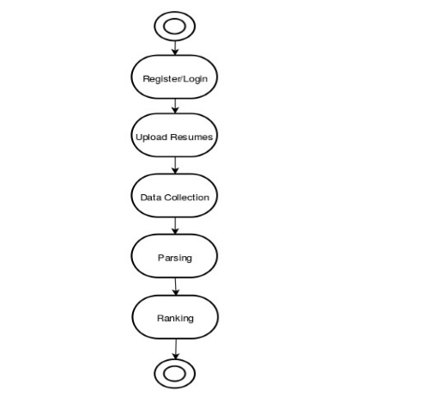

# Business Impact:

Our system will provide better and efficient solution to current hiring process. This will provide potential candidate to the organisation and the candidate will be successfully be placed in an organisation which appreciate his/her skillset and ability.

Manual process is very time consuming. It puts a large work on Incedo HR’s head to look on each and every resumes and then they need to filter it out.

Lots of chances are there to miss out a good profile. It requires an external tool to be loaded for reading the resumes may be (Adobe reader, Microsoft word). But still need to open each and every resumes and then categorize based on the experience and technologies used. It takes a lot of time to find out a suited job profile for Incedo recruitment process.

# Future Scope

The application can be extended further to other process like selection process, interview feedback, and offer release, also to analysis to get better candidates to improve Incedo business.